October 6, 2013

Dear IISB Staff,
       With respect to the norms of KSA ( as per Charter) and in order to maintain the decorum of IISB it is instructed that no male vendor or representative will be allowed to move inside the school premises freely and their movement shall be restricted only up to the reception area. It is also instructed their visits shall be arranged with the due permission of the chairman and the staff should observe proper hijab in their presence. Any kind of negligence in the matter shall be considered as an act of disobedience. Further requested that the staff should wear proper hijab as per the Islamic Preaches, in case of any emergency and essential official work any member of managing committee can visit the school any time with due permission to the Chairman, no blames and excuses will be tolerated in this regards.
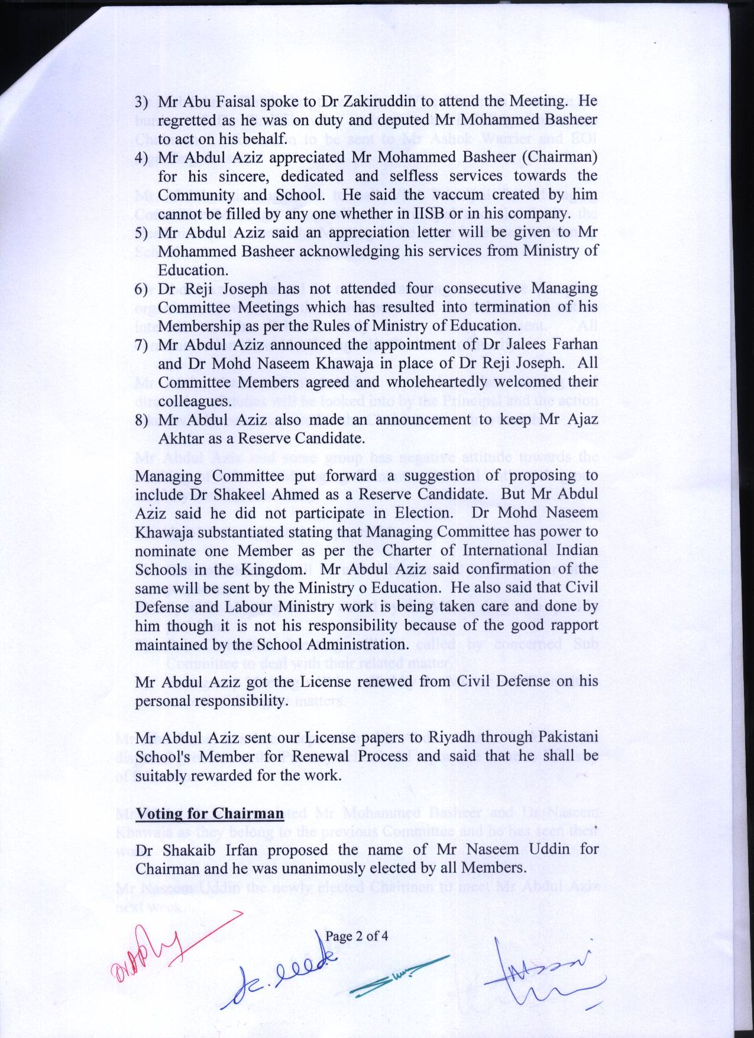
(Naseem Uddin)
Chairman, IISB

