NOTICE
October 29, 2013
Dear Staff,

With reference to the legalization of dependent staff, kindly be informed that the School is working towards it and work permit will be procured for the staff at the earliest.

As per assurance from all concerned authorities, there is no need of concern as long as you are in the School premises. The work permit that will be given will legalise your status and no one will have any hurdle in working and traveling also.

We therefore request all not to panic and create any untoward or embarrassing situation in School and disturb the smooth functioning of the institution.

Unnecessary leaves should not be taken. With reference to your transportation problems, it is requested that if there are no drivers the same has to be managed by yourself in coordination with your husband.

Hoping for a smooth and tension-free environment with your cooperation and support.

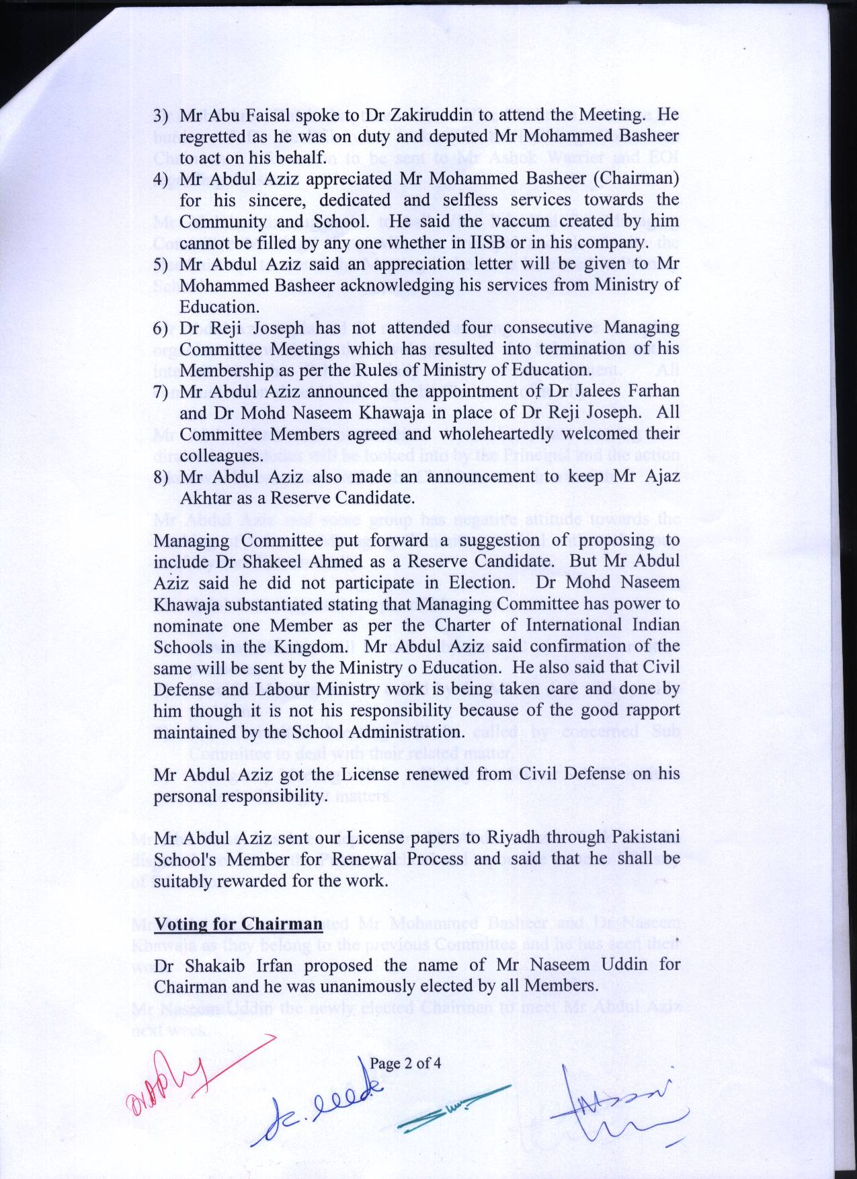
Naseem Uddin
CHAIRMAN

